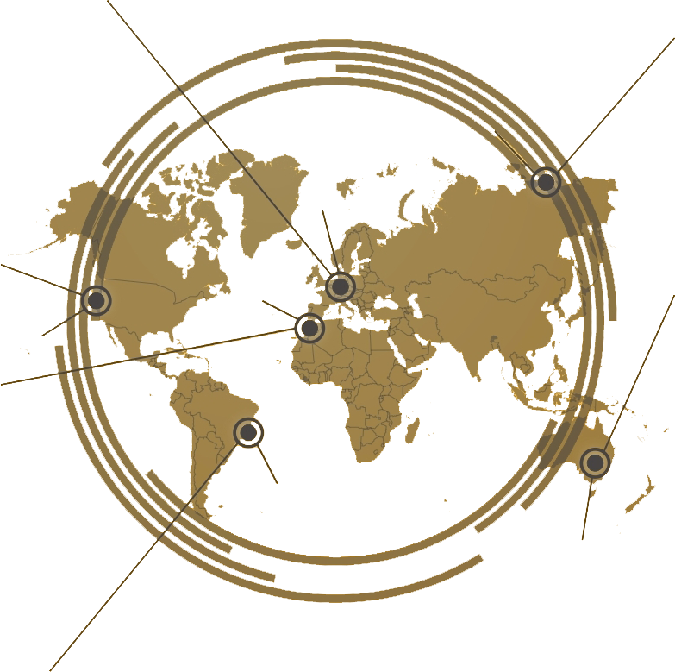
Review Article/Original Research Article (choose one of them) Title of Articles 15 Words Maximum With Times New Roman Font 12pt (bold) in English
author 1¹*, Author 2²
1 Department, Institution, Country, ²Department, Institution, Country

The abstract should be clear, concise, and descriptive. This abstract should provide a brief introduction to the problem, objective of paper, followed by a statement regarding the methodology and a brief summary of results. Abstracts are written in 10 pt Times New Roman and preferably not more than 250 words. 1space.

Keywords: article, template, content, rechtsidee, author guidelines, (max. 6 keywords contain article subject high- lights of article finding or result methods or geospatial coverage)

INTRODUCTION
In introduction, authors should state the objectives of the work at the end of introduction sec- tion. Before the objective, authors should provide an adequate background, and very short lit- erature survey in order to record the existing solutions/method, to show which is the best of previous researches, to show the main limitation of the previous
researches, to show what do you hope to achieve (to solve the limitation), and to show the sci- entific merit or novelties of the paper. Avoid a detailed literature survey or a summary of the results.

ISSN 2503 3492 (online)
*Correspondence:
author 1

Citation: 1 a and 2 A (XXXX) Review Article/Original Research Article (choose one of them) Title of Articles 15 Words Maximum With Times New Roman Font 12pt (bold) in English.
J. Eng. Educ. Society. XX:XX.
doi:

METHODS (FOR ORIGINAL RESEARCH ARTICLE ONLY)
This material and method as much as possible to give an idea to the reader through the methods used (Sa’aati, 2003) (references on this template is just an example). Sub-subhead on this method comprising at least on type of research; location research; materials law source; data collection technique; and data analysis (Coulson, 1968) (Brenner, 1990).

RESULTS AND DISCUSSION (REVIEW ARTICLE USE DISCUSSION)
Results should be clear and concise. The results should summarize (scientific) findings rather than providing data in great detail (Ahmadjayadi, 2003) . Please highlight differences between your results or findings and the previous publications by other researchers. Tables and Figures are presented center, as shown below and cited in the manuscript.

Journal of English Educators Society | ojs.umsida.ac.id/index.php/jees 0 May XXXX | Volume XX | Issue XX

TABLE 1 | Labor Regulations Subjects

Labor agreement | Labor relationship | Industrial relationship | Industrial relation of dispute (Article 1/15 Act 13/2003 jo.
(Article 1/14 Act 13/2003) | (Article 1/15 Act 13/2003) | (Article 1/15 Act 13/2003) | Article 56 Act No. 2/2004)
1. 1. | 1. 1. | 1. 1. | 1. 1.
2. 2. | 2. 2. | 2. 2. | 2. 2.
3. 3. |  | 3. 3. | 3. 3.
 |  |  | 4. 4.
 |  |  | 5. 5.

The discussion should explore the significance of the results of the work, not repeat them. A combined Results and Discussion section is often appropriate. Avoid extensive citations and discussion of published literature.
In discussion, it is the most important section of your article. Here you get the chance to sell your data. Make the discussion corresponding to the results, but do not reiterate the results. Often should begin with a brief summary of the main scientific findings (not experimental results) (Handoko, 2014). The following components should be covered in discussion: How do your results relate to the original question or objectives outlined in the Introduction section (what)? Do you provide interpretation scientifically for each of your results or findings pre- sented (why)? (N. S. B. of Indonesia, 2000) Are your results consistent with what other investi- gators have reported (what else)? Or are there any differences?
Writing using a separation section with numbers. The separation between Title, Sub-Title, Sub-Title Children conducted by Using lowercase letters beginning with a capital letter, typed bold. 12pt Times New Roman, 1.5 space. Using Arabic numerals in the following example (Salam, 2013):
Level 1: 2. Discussion
Level 2: 2.1 Education
Level 3: 2.1.1 Concept of Education
Level 4: 2.1.1.1 Concept of Education in England

CONCLUSION
Contains a description of the conclusions and suggestions that answer questions and formula- tion of the problem with succinctly and clearly. Because, without a description of the clear cover, reviewers are and the reader would find it difficult to give an assessment of your article (G. of
B. Indonesia, 2007)(Arofah, 2012) Do not repeat the Abstract, or simply describe the results of research (G. of B. Indonesia, 2008). Give a clear explanation regarding the possible application and / or suggestions related to the research findings (Multazam, 2010).

ACKNOWLEDGEMENTS
Recognize those who helped in the research, especially funding supporter of your research. Include individuals who have assisted you in your study: Advisors, Financial supporters, or may other supporter i.e. Proofreaders, Typists, and Suppliers who may have given materials.

REFERENCES (a References example)
Ahmadjayadi, C. (2003). Dampak Teknologi Komunikasi dan Informasi terhadap Kegiatan Terorisme. Bandung: Badan Pembinaan Hukum Nasional.
Arofah, L. (2012). Menafsirkan “Hubungan Perdata” dalam Uji Materi Pasal 43 ayat (1) Undang-Undang No. 1 tahun 1974 di dalam Putusan MK No 46/PUU-VIII/2010. Retrieved from www.badilag.net/artikel/11266-menafsirkan

Brenner, R. (1990). Gambling and Speculation A Theory, a History, and a Future of some Human Decisions. Cambridge: Cambridge University Press.
Coulson, N. J. (1968). Islamic Law. In J. D. M. Derrett (Ed.), An Introduction to Legal Systems.
London: Sweet & Maxwell.
Handoko, D. (2014). Interview by Mochammad Tanzil Multazam. Kepala Seksi Penempatan Tenaga Kerja pada Bidang Tenaga Kerja, Perluasan Kerja dan Transmigrasi Dinsosnaker Kabu- paten Sidoarjo: 15 Juni.
Indonesia, G. of B. PBI No. 9/19/PBI/2007 tentang Pelaksanaan Prinsip Syariah Dalam Kegiatan Penghimpunan Dana Dan Penyaluran Dana Serta Pelayanan Jasa Bank Syariah (2007). Bank Indonesia Regulation No. 9/19/PBI/2007: SG No. 165 Dpbs.
Indonesia, G. of B. SEBI No. 10/14/DPbS Tentang Pelaksanaan Prinsip Syariah dalam Kegiatan Penghimpunan Dana dan Penyaluran Dana serta Pelayanan Jasa Bank Syariah (2008). Bank Indonesia Circular Letter No. 10/14/DPbS.
Indonesia, N. S. B. of. DSN No.04/DSN-MUI/IV/2000 tentang Murabaha (2000). Fatwah of National Sharia Board NO: 04/DSN-MUI/IV/2000.
Multazam, M. T. (2010). Pemanfaatan Video Konferensi Dalam Pembuatan Akta Notaris.
Magister Kenotariatan Universitas Airlangga.
Sa’aati, A. R. Al. (2003). The Permissible Gharar (Risk) in Classical Islamic Jurisprudence.
Journal of King Abdulaziz University: Islamic Economics, 16(2), 3–19.
Salam, A. (2013, February 8). Berisiko, Sengketa Anak Zina di PA. Jawa Pos. Surabaya.

Nb.
- References style
- Cite the main scientific publications on which your work is based.
- Cite only items that you have read and on footnotes
- Do not inflate the manuscript with too many references.
- Avoid excessive self
- Avoid excessive citations of publications from the same region.
- Check each reference against the original source (authors name, volume, issue, year, DOI Number).

Please use Reference Manager Applications like EndNote, Mendeley, Zotero, etc. (we suggest Mendeley)

Conflict of Interest Statement: The authors declare that the research was conducted in the absence of any commercial or financial relationships that could be construed as a potential conflict of interest.
Copyright © XXXX 1 and 2. This is an open-access article dis- tributed under the terms of the Creative Commons Attribution
License (CC BY). The use, distribution or reproduction in other forums is permitted, provided the original author(s) and the copyright owner(s) are credited and that the original publica- tion in this journal is cited, in accordance with accepted aca- demic practice. No use, distribution or reproduction is permit- ted which does not comply with these terms.

